# RMBL Phenology: The effects of a changing climate on migrating and over-wintering species at a high elevation field station (Answer key)

Adapted from: Carrie Wu and Amy Ellwein. 2017. The Biology of Climate Change: The effects of a changing climate on migrating and over-wintering species at a high-elevation field station. Teaching Issues and Experiments in Ecology, Vol. 13: Practice #2 [online]. <http://tiee.esa.org/vol/v13/issues/data_sets/wu/abstract.html>. doi:10.25334/Q4X696

## [Link to the visualization](https://huckley.shinyapps.io/RShiny_RMBL-phenology/)

## [Link to TrEnCh-Ed](https://trench-ed.github.io/#)

Learn more about this research:

* [The Hermit Who Inadvertently Shaped Climate-Change Science](https://www.theatlantic.com/science/archive/2017/01/billy-barr-climate-change/512198/)
* [Climate change is affecting altitudinal migrants and hibernating species](https://www.ncbi.nlm.nih.gov/pmc/articles/PMC26486/)
* [The Snow Guardian](https://vimeo.com/182392548)
* [Time-lapse of snowpack at Snodgrass Mountain, CO.](https://www.youtube.com/watch?v=LCcbWK3UAUE&feature=youtu.be)

## Objectives

* How does climate change affect the phenology of species in a high-elevation ecosystem?
* How might these changes in temperature and snow melt impact ecological interactions?
* The broader goals of this activity are to help you strengthen skills in: evaluating scientific figures, understanding statistical significance and regression, testing a hypothesis with a long-term dataset

## Core Concepts -- *BioCore*

* Ecology & Evolutionary Biology: Structure Function
* Ecology & Evolutionary Biology: Systems

## Instructions

First, read through the RMBL Phenology introduction in the visualization. This will give you the required background information for these exercises. Then, answer these questions from the readings:

1. Numerous scientists have determined that the growing season is starting earlier at lower elevations. What did Inouye and colleagues determine was happening to the start of the growing season in the high Rockies around RMBL from the 1970s through the 1990s? Provide support for your response from Inouye et al. (2000).

The beginning of the growing season has not changed significantly since 1973. In the paper, they state that the growing season begins only after the snow disappears. Data showed that the first date of bare ground in the spring also has not changed significantly over the decades.

1. How, if at all, do you think what Inouye observed might affect migrating species that visit the high Rockies in the summer? What about hibernating resident species?

Migrating species are arriving earlier in the season as they respond to increasing temperatures. This causes them to arrive before the snow melts. Similarly, hibernating animals partly depend on air temperatures for the timing of their emergence and can wake up before the snow melts. This phenological mismatch can decrease their fitness due to a lack of food.

### Part A. Change over time

For these questions, we will use the first “vs Year tab” and a time period of 1974 - 1999. All data come from RMBL. Look at the trendline analysis beneath the plot to determine the rate of change per year and the significance of the relationship.

1. Using the RMBL Phenology visualization, produce three plots (Figures 1, 3, and 4), from Inouye et al. (2000).

* Annual snowfall (cm)from 1974 to 1999
* Date of the first sighting of the American robin from 1974 to 1999
* Date of the first sighting of the yellow-bellied marmot from 1974 to 1999

For each of the relationships depicted in those three figures, determine:

* What is the rate of change per year?
* Is this rate of change (relationship found between the variables) significant? What supports your conclusion?

Plot 1.

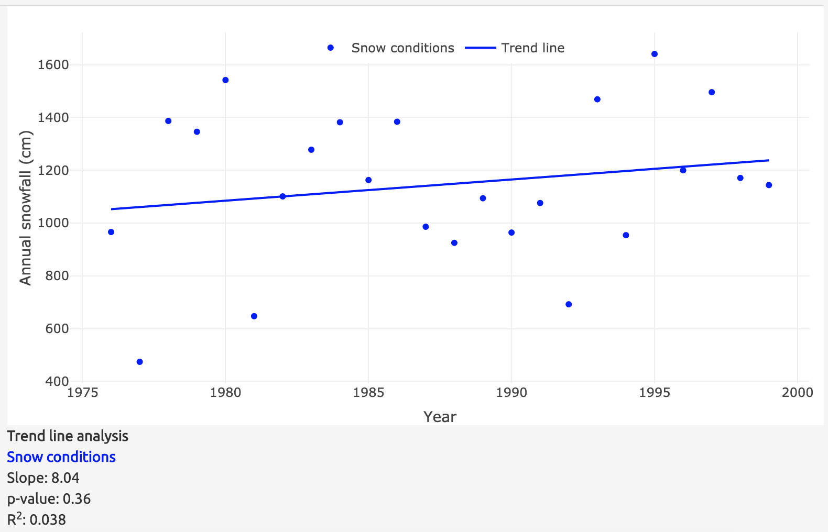

The rate of change is 8.04 cm per year and is not significant due to p-value > 0.05 and R2 < 0.2.

Plot 2.

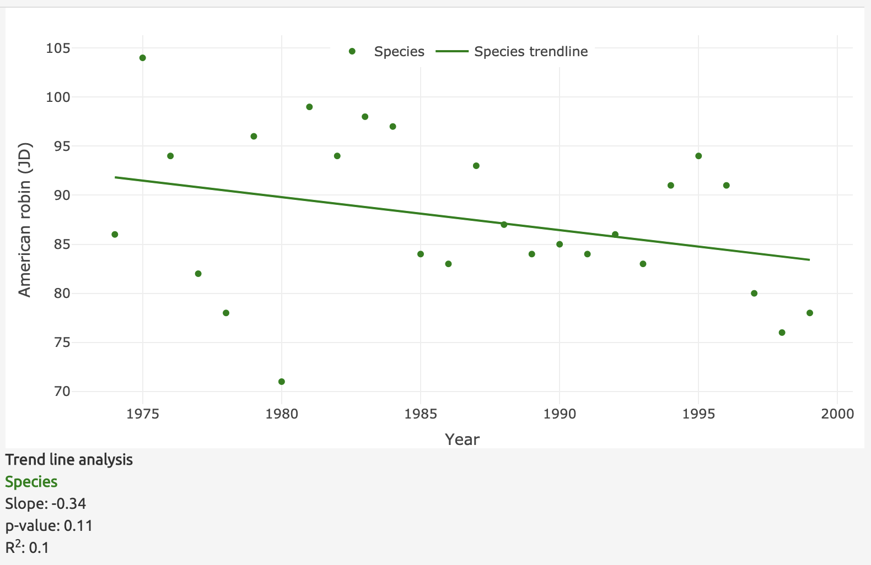

The rate of change is -0.34 JD per year and is not significant due to p-value > 0.05 and R2 < 0.2.

Plot 3.

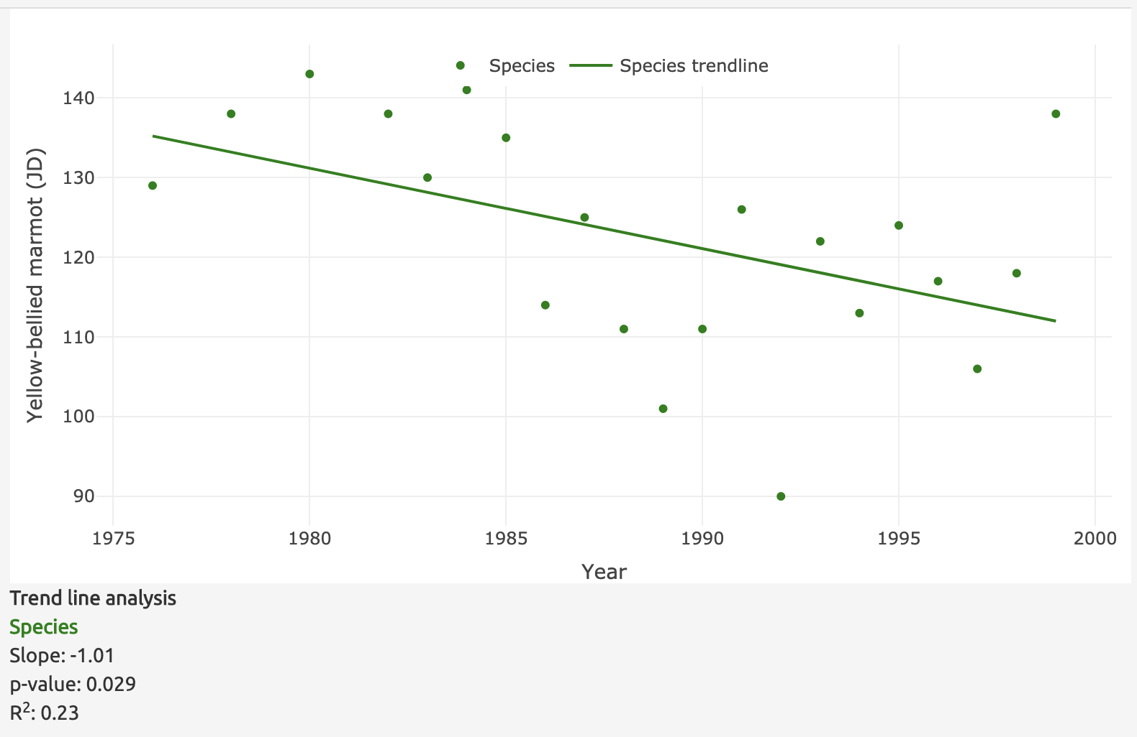

The rate of change is -1.01 JD per year and is significant due to p-value < 0.05 and R2 > 0.2.

Do you see similar trends across all three relationships? If not, explain how they differ.

Annual snowfall and the first day of sighting of American robins have not significantly changed over the years while the yellow-bellied marmots are sighted earlier over the decades.

1. Have these trends held over the **longer term**? Choose either your earlier plot of the American robin or the yellow-bellied marmot to re-examine. Determine if the trends observed have held up in subsequent years by using two new time frames and generating plots with the new timeframes:

* An extended data set (1974-2010)
* The most recent decade (2000-2010)

American Robin 1974 - 2010

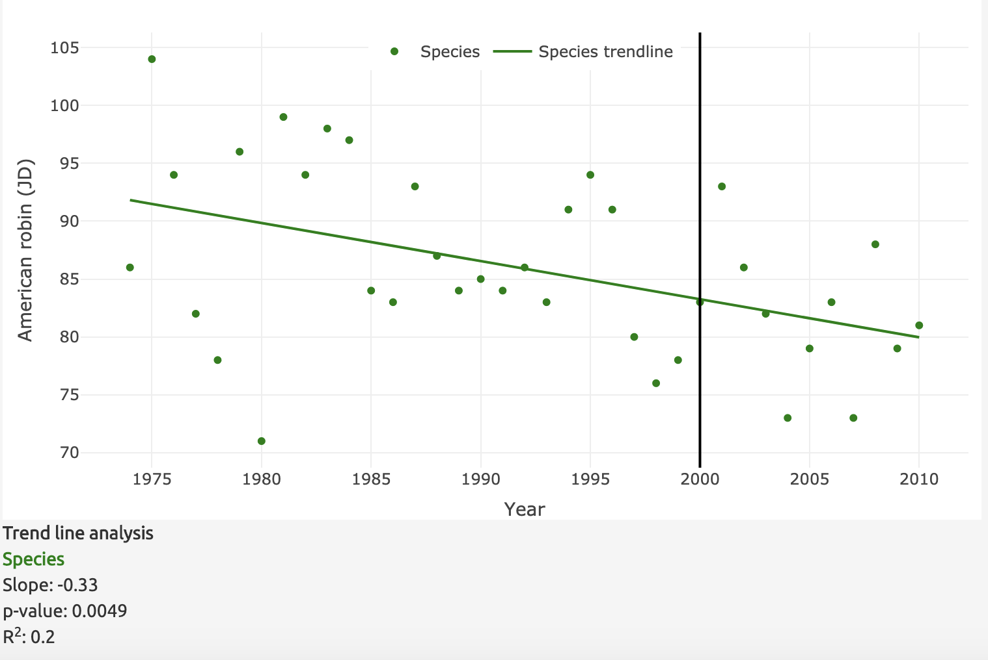

The rate of change is significant, due to p-value < 0.05 and R2 >= 0.2.

American robin 2000 - 2010

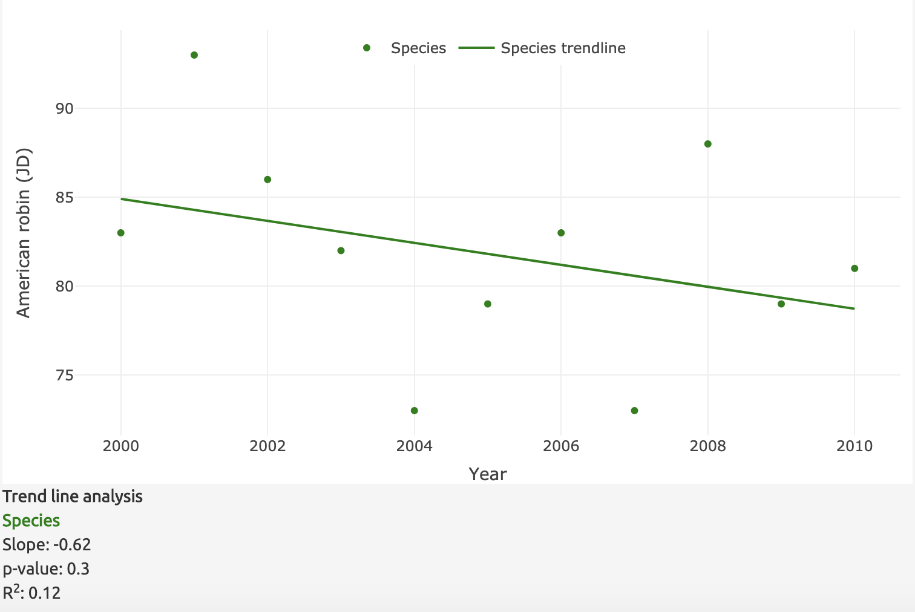

The rate of change is not significant, due to p-value > 0.05 and R2 < 0.2.

Yellow-bellied marmot 1974 - 2010

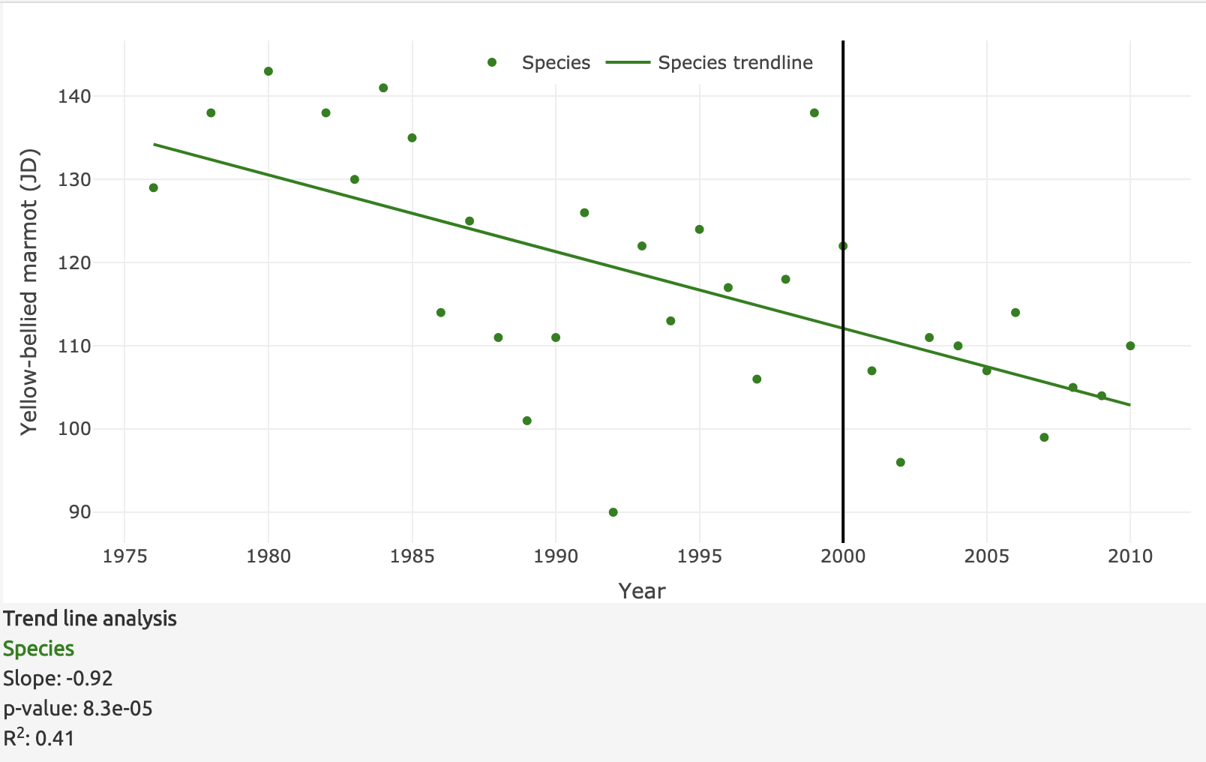

The rate of change is significant, due to p-value < 0.05 and R2 > 0.2.

Yellow-bellied marmot 2000 - 2010

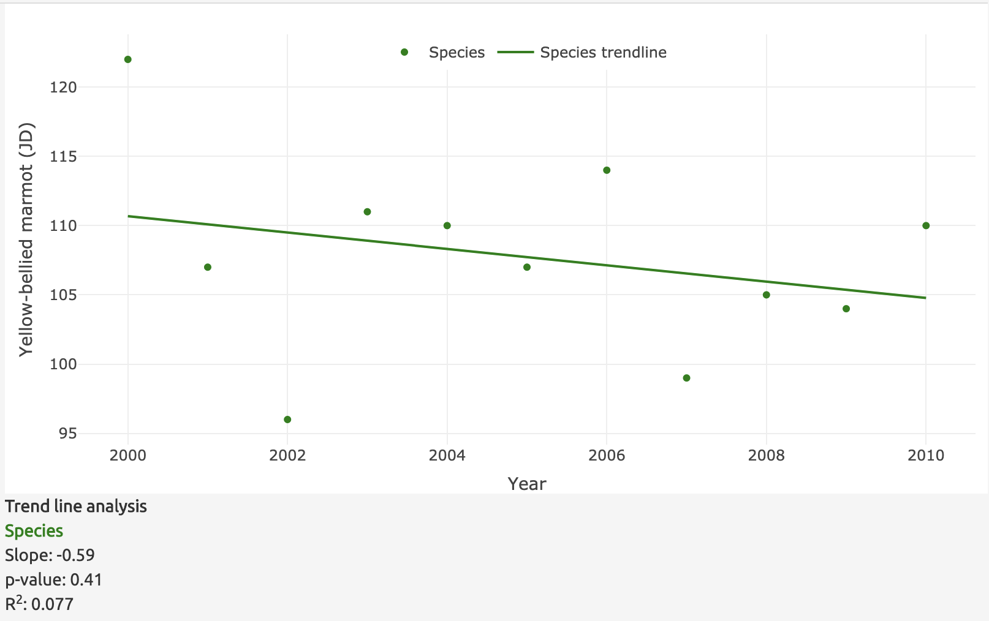

The rate of change is not significant, due to p-value > 0.05 and R2 < 0.2.

1. Describe how the new plots you produced in question 4 **differ** from the plots you produced in question 3 (which were in Inouye et al. 2000). Do the original plots support the original interpretations? Justify your reasoning. Do the updated plots suggest new interpretations?

The 2000 - 2010 plots follow the same trend that the first sightings of the animals are becoming earlier on average, but the rates of change are not significant. However, the longer time series shows that the rates of change are significant for both species. This rejects the initial interpretation of the American robins and further supports that of the yellow-bellied marmots.

1. How have **abiotic** (non-living) conditions changed over the extended period of record?

The snowmelt date, annual snowfall, nor the average snowpack have significantly changed. This follows the results from Inouye et al. 2000 paper, which discussed how high-elevation climates are relatively static compared to low-elevation climates. Thus, migrating and hibernating organisms may be experiencing phenological shifts that do not align with snow conditions.

1. What are your predictions for future change?

One example (open-ended):

As climate change progresses, we can predict that the temperature keeps increasing and migration occurs earlier and earlier. At some point, the phenological mismatch will be too large that individuals that happened to have a higher tolerance to heat and migrate later in the year will have a substantially higher fitness over the others that migrate early. Through natural selection, some migrating species can potentially evolve to be more tolerant of heat and allow them to migrate later.

### Part B: Phenotypic change due to abiotic changes

Go to the “vs snow conditions” tab for the next plot you’ll generate. This plots the date of the first sighting of an organism on the y-axis and the snow condition on the x-axis. Use the 1974-2010 extended time period and the snowmelt date as your snow condition. Choose any organism you want to plot its first sighting date, but ensure that the relationship plotted is significant.

1. For your organism, how much would its date of first sighting shift with a 5-day earlier snowmelt date?

Ensure their trend is statistically significant. Below is an example of a correct calculation:

Red-naped sapsucker

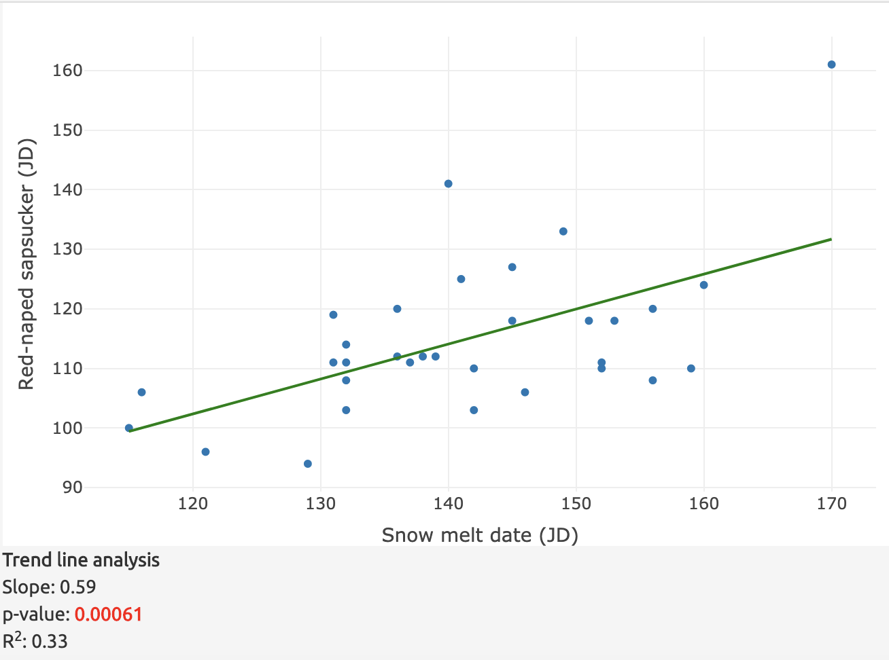

If the snowmelt date is 5 days earlier, you can expect a 0.59 * 5 = 2.9 days earlier first sighting of the Red-naped sapsucker.

### Part C: Generate and test a new hypothesis using the climate and phenology data

With your understanding of phenology and the visualization, here’s your chance to ask and answer your own questions. Feel free to use any organism and any snow conditions or (other weather conditions found in the “vs other weather conditions” tab).

Open-ended questions

1. Frame a question that you think you can answer using the data set that extends through 2010.
2. Generate one or more graphs to test your hypothesis.
3. Is the relationship significant? Is your hypothesis supported by the data?